Introduction

The following is a ten-week curriculum designed for Foxboro youth soccer. It is intended to be used as a coaching aid and not a schedule. It is a resource that the coaches can use to help their team improve in certain focus areas. It includes warm-up games that can take place at the start of s session progressing into games, and for the older age groups there are exercises. Games are intended to be a fun way of learning in soccer that still includes a level of technical involvement. The exercises are much more technique based, working on the fundamentals of soccer, they are still intended to be enjoyable however. The curriculum contains ways of progressing games if a session is going well and the coach wants to elongate the focus of the practice. There are also soccer features intended to address some of the protocols in soccer that sometimes generate confusion. They simply explain what happens in certain situations in soccer. In this way the curriculum is intended to be accessible to coaches of all levels covering the basics of the game up to the advanced methods of coaching.

It works on the following fundamentals

- Passing and control
- Dribbling
- Defending
- Attacking
- Goalkeeping
- Shooting and Goal scoring
- Passing (2) Passing as a team
- Dribbling (2) Advanced dribbling
- Defending (2) Defending as a team
- Attacking (2) Attacking as a team

With this level of players, the curriculum covers a wide array of topics and areas of focus. The core fundamentals of passing, dribbling, defending and attacking receive double focus as they form the main skill base of a player’s ability.

The sessions include a fun, high energy warm up to get players ready for some technical work. After technique they move into a fun game to keep up the momentum of the session. This will be followed by some more technical work leading to scrimmage. In this way the session remains interesting for the players.

Sessions are designed with 60-75 minute duration.

It is recommended and advised that players spend at least the first 10 minutes of each training session individually with the ball working on basic foot skills as outlined in the U10 Curriculum.

All sessions should end with an even sided game to goal with an emphasis on the training topic.

Foxboro Youth Soccer
U12 Curriculum

Week 1-Passing and Control

Aim: To be able to receive the ball keeping it under control and to make passes with accuracy and appropriate power to a teammate

Skills
- Inside of the foot
- Laces
- Outside of the foot
- Back heel pass

Key Principles

Standing foot (non-kicking foot) close to the ball

Follow through after the pass is made

Strike the center of the ball.
- Use Inside of the foot to receive a pass
- Keep the ball close enough to maintain possession
- First touch however, should not be too close to the player, as the ball will get stuck under their feet.
- The pass should be close enough to the player who is receiving the ball
- The pass should lead the player into space
- Players must have their heel down and toes up when passing and the same when receiving.

Warm-up:

Tunnel Tag
All but one player has a ball. The player without the ball is a tagger. Players who have been tagged must stop and place their soccer ball on their head with their legs open; they are set free when another player passes the ball between their legs.

Games:

Foxes and Hunters
Place all the balls in a pile outside the square. Two players have a ball at their feet (hunters). All the other players are without a ball (foxes) inside the square. The hunters must try and catch the foxes by passing the soccer ball at them and hitting them below the knee. Once a fox is hit they become a hunter.

Passing Gates
Set pairs of cones three feet apart in large area. Players work in pairs to get to as many “gates” as possible. Once at the gate, they must make a double pass before heading to a different gate. Goal is to get to as many different gates with accurate passing in the allotted time.

Exercise:

Passing Partners
Put the players in pairs facing each other. They should have a ball between two. Spend time going over appropriate technique by getting them to exchange passes.

These exercises can be done with players 5-10 yards apart and include movement towards a rolling ball. Pass and move. Or pass and follow. This should not be done in stagnant or standing lines.

- Inside of the foot –
- Approach from the side
- Standing foot close to the ball
- Strike the middle of the ball and follow through
- Keep your eye on the ball.

- Laces –
- Approach the ball straight on
- Place the standing foot next to the ball
- Point the toes down
- Strike through the center of the ball
- Follow through after pass

- Outside of the foot –
- Approach the ball straight on
- Place the standing foot next to the ball
- Point the toes down
- Strike the inside of the ball (closest to the standing foot)
- Follow through after pass

- Back heel
- Stop the ball
- Place the support leg next to the ball
- Heel the ball with a putting motion
- Sprint off after the pass

Corners
Split the players into four teams. Each team forms a line facing inwards in each of the corners of the square. There are two balls for the four teams. The first player from each team with a ball dribbles out diagonally towards the middle of the square. When they reach the middle they pass to the player at the front of the line opposite them. This player then receives the ball and dribbles it back towards the opposite corner and passes it diagonally once again. Progression can be adding two more balls, which will increase the speed of the drill.

Coaching Points

- Good communication to avoid a collision in the middle of the square.
- Accurate passes rather than hurrying the pass makes for a quicker drill.
- Good first touch from player receiving ball towards middle of square.

Game: 6 v 6 game, with the emphasis on dribbling and passing.
.
Soccer Feature: Throw-ins
Explain when and how to take a throw in and link it into the passing theme of the day. Explain the correct technique of having both feet planted on the ground and releasing the ball ‘behind the head’

Week 2-Dribbling

Aim: To encourage close control of the ball whilst dribbling, using the correct parts of the foot

Skills
- Inside of the foot dribbling
- Laces dribbling (toes down)
- Sole dribbling
- Outside of the foot dribbling
- Fakes and turns

Key Principles

- Players should keep the ball close at all times using many small touches on the ball rather than fewer larger ones, unless sprinting into open spaces
- Encourage the players to look up as they dribble in order for them to find space and make better decisions with the ball
- Players should push themselves speed wise, but without losing control. They need to keep their upper body over the ball when in control

Warm-up:

Body Parts
Every player has a ball. Players dribble their ball around the square. The coach will then shout out the name of a body part (e.g. knee) the players must then try and put that body part on the ball. Introduce the skills into the game by using the different parts of the foot and then progress onto different things like head!

Games:

The Freeze Game
Players dribble their ball around the square. The coach can start by shouting freeze. Then the coach can progress the game by taking a cone in their hand. When the coach holds the cone in the air the players must stop their ball and freeze. When using the cone the coach should not say anything whenever they put up the cone and must move around the square throughout the game. This progression gets the players’ looking up as they dribble, whoever stops first wins!

Exercise:

Shuttle runs

Players form groups of three two with ball ten yards apart from the third. The first player A dribbles at speed to the third player B, lays the ball off then runs around them to receive the return pass, then accelerates and dribbles towards player C, laying it off for player C to dribble towards B.

Gate Race
Make several gates inside the square. Every player has a ball. The players must try and dribble around the square going through as many gates as possible in the time limit provided by the coach. Let players keep count of their score, which will encourage them to speed up the drill. Progress the game by putting conditions on the players’ dribbling e.g. insides only, opposite foot etc.

Coaching Points

- Many small touches to be taken to keep the ball inside the square
- If a gate already has a player dribbling through it, select another gate (dribbling into space)
- Keep the head up when dribbling to find free gates and avoid collision
Fakes and Turns
Players have a ball each and are dribbling around the square, on the coach’s command players can perform one of the fakes listed below. To progress the exercise, the coach can have players pass and move with a ball between two. On the coaches command the player that has the ball at the time of the coach’s signal can turn and face their partner and try and dribble past them using a fake.

- Shoulder Drop –
- As the ball carrier reaches the defender they bend their left knee and lower their right shoulder
- They then push of the bent knee and accelerate to the right

- Scissors –
- The ball carrier steps over the ball with their left foot
- As they do so they lower their left shoulder
- They then push off the bent knee and accelerate to the right

- Inside Outside –
- As the ball carrier approaches the defender they touch the ball with the inside of their foot
- As quickly as they can after that they touch the ball back with the outside of the foot and accelerate

Coaching Points

- Players should wait until the defender is close to them to perform a fake in order to give them less time to react.
- Players should accelerate quickly away from the defender after the fake
- Players must shield the ball away from the defender for these moves to be effective

Game: 3 v 3
Players use small sided goals to attack and defend 3 v 3.

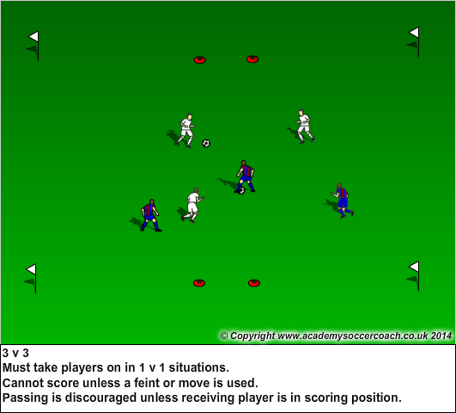

Game: 6 v 6 or 8 v 8 game, with the emphasis on taking players on.

Soccer Feature: Goal Kick
Explain how and when you would conduct a goal kick with regards to positioning of both attacking and defensive players.

Week 3-Defending

Aim: To help players to be able to pressure the ball carrier in an attempt to dispossess them

Skills
- The ‘Side on’ position taken to allow quick change of direction
- To get close enough to a player to cause them to take a ‘bad’ touch
- For the defender to stay on their feet and not slide in

Key Principles:

Deny (ball, penetrating pass)
Delay (attacker)
Destroy (tackle, dispossess)
Develop (counterattack)

- Players closest to the ball should put immediate pressure on the ball carrier whilst not getting too close, as this reduces the amount of time for the defender to be able to react.
- The defender should try and poke at the ball and force the ball carrier into a wide position away from the goal.
- Players should always keep their eye on the ball not the player
- Stress the importance of balance, defenders should try to approach sideways on and not square. It is very important that their weight is on their back foot and not their front.
- Defenders should use feints at poking the ball to get the attacker to react thereby creating a tackling opportunity.

Warm-up:

Call The Defender
Every player has a ball that they are dribbling around the square. The coach calls out the name of a player and they then must try and tag as many players as possible. When tagged the players must leave the square and perform a skill of the coach’s choice e.g. 5 juggles. The defender must be rotated regularly.

Games:

Combat
Split the players into two teams. The two teams are put inside two squares with a ball per team and are passing and moving. Each player has a number that corresponds with that number on the other team. When the coach shouts out the player’s number they both rush out of their square after a ball rolled into a neutral area by the coach. They must compete to win the ball and try and score into the designated goal.

1v1 to Cone Goals

Players pair up with a ball. Each player is defending their cone goal (3ft) while attempting to attack their opponent’s goal. Game is to time or first to two goals.

Exercise:

1 v 1 Channel
Make several channels inside the square. Two players per channel, with a goal at either end. There is one ball per channel. The defender starts with the ball and plays a pass to the attacker at the other end of the channel. The attacker must then try and score in the defenders goal. The defenders must try and stop them. Rotate players regularly.

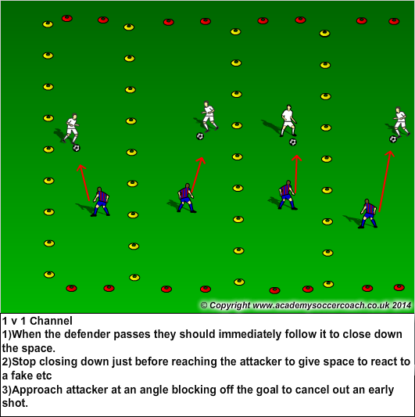

Defenders Roles Defined:

The role of the first defender is to yell “I’ve got ball” while applying pressure.
The role of the second defender is to provide cover or support and communicate with the first defender
The role of the third defender is to provide balance and orchestrate the first and second defenders while giving support and preventing penetration.

Communication: It is very important that the defenders communicate with each other, beginning with the first defender to reach the attacker.

3 v 2 Defending

There are three attackers who have possession of the ball. They will make passes to try and keep the ball away from the two defenders. You can add conditions into the game such as:
- The attackers must make 5 passes to get a point
- If the defenders touch the ball the attackers lose a point.
- If the ball goes outside of the square then the attackers have lost control and the defenders again get a point.

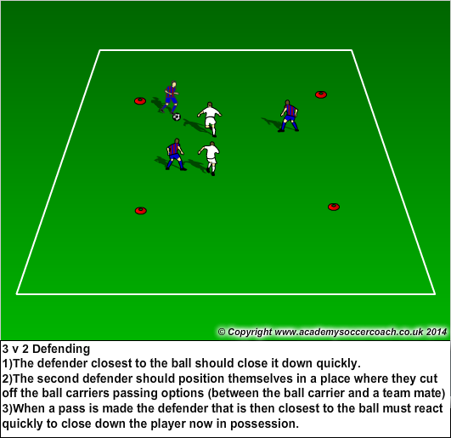

Game: 6 v 6 or 8 v 8 with the emphasis on defending
Soccer Feature: Free kick
Explain when a free kick is awarded (after a foul) and that the ball must be stationary when kicked. Explain indirect and direct free kicks. You can shoot from a direct free kick but the ball must be passed first before a shot when taking an indirect free kick.

Week 4-Attacking

Aim: To introduce attacking skills in a game like environment

Skills
- Keeping the ball as close as possible when dribbling, even at accelerated speeds
- Remembering the different parts of the feet used to dribble the ball, in order to keep the ball as close as possible

Key Principles:

- When the players dribble under pressure it is important for the players to maintain control of the ball by touching the ball regularly.
- It is important that they try to remain composed and dribble towards space quickly.
- Players should spread out away from the ball carrier to receive a pass
- Players vary their runs to get into space quickly

Warm-up:

Nutmeg race
Split the players into 2 groups (team 1 and team 2). Only team 1 has a ball to begin with. Team 2 stands with their legs apart as team 1 races around and tries to get as many nut megs (a pass between the legs) as possible in the time limit. Then switch the teams.

Games:

Crab Soccer
Players are divided into two even teams. Team A has a ball each, while Team B is on the ground in Crabs positioning defending the goal line. On coach’s command, Team A attempts to dribble their balls past the Crabs (Team B) and over the goal line. Switch and repeat when completed.

Escape
5 soccer balls are placed in a row 5 yards apart and 40-60 yards away from an identical set. Two teams are assigned to attempt to steal the other team’s ball while protecting their own. Players are put in prison if tagged while attempting to steal the balls which can only be captured by dribbling them away over the neutral border. Players can escape if they are tagged by their team with or without the ball.

Exercises:

Triangles
Make three triangles inside the square. The three sides to the triangle are all goals. There is one goalkeeper inside each triangle. The rest of the players have a ball each. The players must race around the square to score as many goals as possible in any sides of the triangle. The goalkeepers must try and save as many shots as possible. The winner is player with the most goals at the end of the drill. Progress the game by playing in pairs.

Coaching Points

- Players must find space inside the square and dribble into it quickly before it is taken up
- A shooting opportunity should be taken as soon as possible
- Accurate shots with less power will help as the ball will not leave the square after the shot is made
- When a player is on the edge of the square a turn should be encouraged to face a goal quickly

5 v 3 Attacking

5 players with one ball attempt to attack a goal line that is 40 yards away. Three defenders attempt to defend the line preventing the ball from crossing or dispossessing the attackers. If successful, the defenders then attack the opponent’s goal line with the ball.

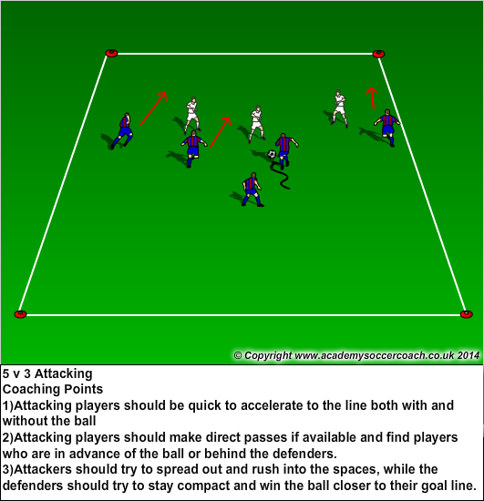

Game: 6 v 6 to Goals
Emphasis is on attacking spaces with and without the ball.

Soccer Feature: Positioning
Set up players in recognized positions on the field and explain that players’ purpose. Show goalkeepers, defenders, midfielders and forwards. You can then try and use these positions in a game situation.

Week 5-Goalkeeping

Aim: To introduce and demonstrate the differences of being a goalkeeper and an outfield player and introduce basic handling principles.

Skills
- Goalkeepers can use their hands inside their own penalty area
- Ready position with knees bent and hands in the “piano” position (hands flat and face down)
- Goalkeepers should be on the toes to allow them to adjust body weight quickly
- Use the thumbs to make a ‘W’ shape when catching the ball
- Players should try and catch the ball when possible to keep possession of the ball

Warm-up:
Goalie Skills-Some different goalkeeper exercises to learn about the position.

Goalie Tag
There is one tagger. There are also two players with soccer balls that run around the square with the ball in their hands. If a player with a ball in their hands sees someone that has been tagged they can throw the ball to that person and when they catch it they are unfrozen. That player keeps the ball and the game continues until another person is tagged.

The Reaction Game
Start with one ball between two players. One player holds the ball and the other player has their hands by their sides. The player holding the ball will drop it un-announced and the other player has to try and catch it before it hits the floor.

Games:

Multi-Goals
Make four goals in square. Split the soccer players into 4 groups and put one group in each goal. Every player has a ball. They can use this ball to try and score in any of the other goals by using an under arm goalkeeper roll. The players must also try and save the shots from the other teams.

Double Goalie Game
Get the soccer players in groups of three with two balls. There is a goalkeeper in the goal with two players with balls either side of the goal. When one player shoots at the goal the goalkeeper can then turn around and face another shot from the other striker in quick succession to help with reactions. Rotate the goalkeepers regularly.

Team Handball
Split the soccer players into two teams. Players use their hands at all times. They must try and score in the goals using their hands like handball. When they are in possession of the ball they cannot take more than three steps and must try and make a pass by throwing the ball to a teammate. GKs in goal.

Goalie In The Middle
Select three goalkeepers. Split the rest of the players into two teams. Divide the square into three equal sections. The goalkeepers occupy the middle section whereas the two teams are in the two end sections. There is one ball. The two teams on either end of the square must try and pass the ball through the middle section with the goalkeepers in it, to the team on the other side. The goalkeepers must try and stop the pass getting through. Place a condition of the game of keeping the ball below head height. Progress the game by adding more balls.

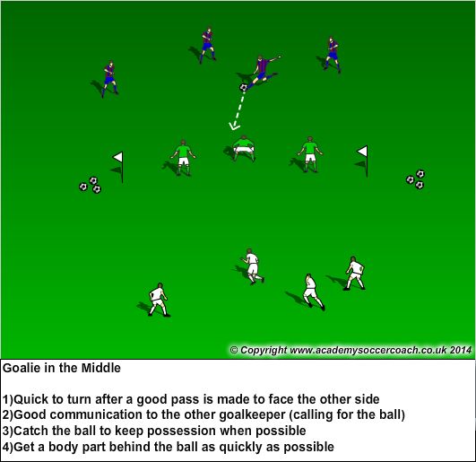

Bobble Trouble
Players are in pairs using a goal. One is a goal-keeper, the other player is the attacker. The goalkeeper has cones placed just in front of their goal. The attacker shoots along the ground towards the goal. The ball will hit some of the cones on the ground and will deflect off them, changing direction at the last minute. This makes it harder for the goalkeeper to react to the shot. Progress by getting the attacker to follow the shot in, to score any rebounds.

Coaching Points
- The goalkeeper should try and catch the ball whenever possible. This allows their team to win possession
- If the goalkeeper cannot catch the ball they should parry it away from the goal area, this is so that the attacker cannot score an easy rebound

Game: 6 v 6 or 8 v8 Team Handball
Soccer Feature: Dealing with adversity- Injuries
Explain that injuries are part of the game and the importance of returning when fully fit.

Week 6-Shooting and goal scoring

Aim: To score goals by encouraging accurate shots that are away from the goalkeeper and on the goal frame.

Skills:
- Inside of the foot shot
- Laces shot
- Dribble and shoot
- Inside of the foot shot with curl

Key Principles:

- Players should get their body weight over the ball
- They should maintain eye contact with the ball throughout the shot
- They should not lean back.
- The ankle should be locked and the toes should always be pointed down.
- Accuracy over power should be encouraged.
- Strike through the ball then follow through with the leg for more power
- To curl the ball players should strike the outside of the ball rather than the center

Warm-up:

Soccer Tennis
Players pair up and juggle the ball one bounce to each other using the instep (laces) to strike the ball.

Games:

Missiles
Players have a ball each. Players are dribbling around the square and when the coach shouts fire, each player must try and shoot and hit any other player’s soccer ball.

Scoring Race
Split the players into two teams that stand in two lines in front of the goal. The coach then serves a ball in between the players and the both compete to score. Progress by adding fun elements to the game such as players must start from the sitting down position etc.

Exercise:

Continuous Shot
3 players with one ball. One player is the goalie in the middle of a 10ft cone goal and the other two alternate between shooting and becoming the goalkeeper themselves. Continuous play.

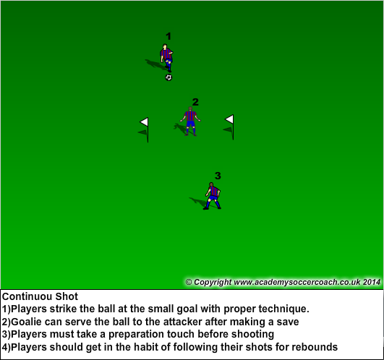

1v1 Shooting and Finishing
Players are divided into two teams. They are positioned at the goalpost and must race around the cones 15 yards out to receive a ball and try to score.

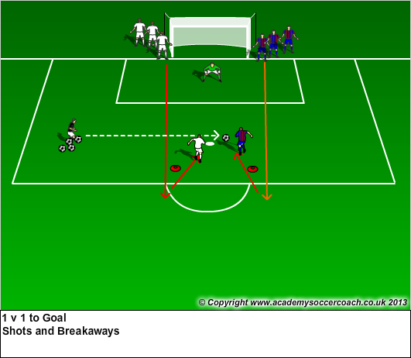
4 v 4 Shooting
Split the players into two teams each with a goal-keeper. Goals are 30 yards apart. Teams must score with every possible opportunity from that distance and under pressure. The goal here is to create scoring opportunities directly and indirectly from shots on goal.

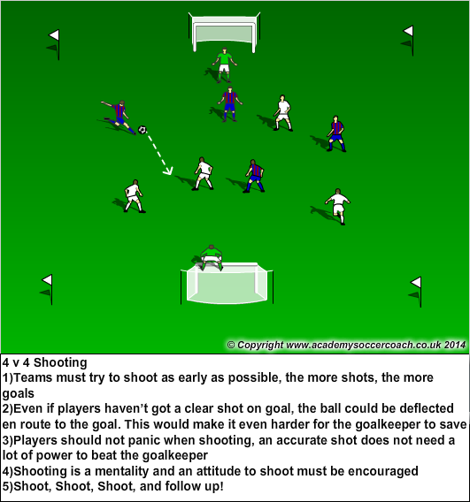

Game: 6v6 or 8v8 to Goal
Game with the emphasis on shooting and finishing

Soccer Feature: Penalty kicks
Explain when they are awarded and how they are taken. They are awarded when a foul is incurred inside the penalty area (goalkeeper’s area). When they are taken the goalkeeper must be standing on the goal line, with all other players standing behind the penalty kicker.

Week 7-Passing (2)

Aim: To continue the reinforcement of appropriate technique when passing, even under pressure. To build on the skills learnt from the previous passing session.

Skills:
- On top of using the appropriate part of the foot to pass, look at the accuracy and selection of each technique for the correct situation e.g. short passes (inside of the foot), longer pass (laces pass)
- Use of communication when passing is very important, an understanding of where a pass is going to be made to will minimize the effect of an errant pass.
- The selection of who the pass is to is important, making sure that they are in a good position to receive the ball

Key Principles:

- Players should communicate where they want to receive the pass.
- Communication is not just talking; it can even be pointing to the spot in which they want to receive the pass.
- Passes in a game situation should be in front of the player.
- This means that if a pass is made to where the player is going they can continue their momentum when running rather than having to stop and receive the pass.
- Quick short passing can allow teams to break effectively for good transition

Warm-Up:

Pass & Move
In pairs, players pass the ball, sprints away and calls for the return pass. Vary distance and surfaces used to pass.

Games:

Wall Pass Elimination
Split the players into two teams. Each team is divided into pairs with a ball. Teams attempt to wall-pass around the other team’s players thus eliminating them. Team with the last pair not to be “walled”, wins.

Meg Pass
Players with one ball in pairs dribble around in space. Coach calls “Meg!” and the player with the ball must attempt to pass the ball thru the legs of his partner (who stands feet apart) no matter their distance apart.

Exercise:

Ring of Passes
Split the players into two teams. One team stands around the outside of the square. The other team is inside the square with a ball each. The team on the inside should pass and receive with the team on the outside looking to move all the way around the circle eventually making a pass to everyone. Rotate the teams regularly. Progress by getting players to make one time passes. Progress further by changing the types of passes played e.g. outside of the foot.

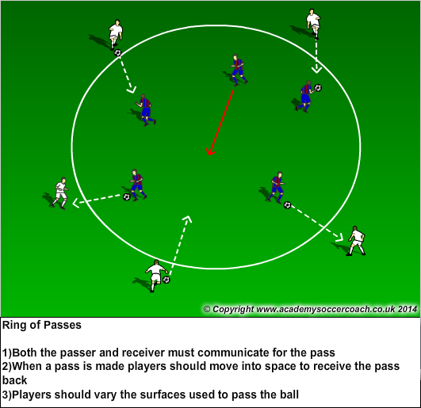

Cross the Border

Two teams of 5 v 2 attempt to score by making 5-10 consecutive passes to each other before the other team intercepting the pass. Progress to having the defending team “Cross the Border” after gaining possession provided that one attacking player switches to defense. Goalkeepers can be used as an additional defender. Defenders that win the ball can pass to the opposite grid to their teammates, or dribble over the border.

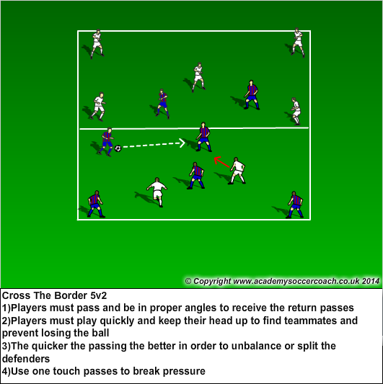

Game: 8 v 8 game, with the emphasis on passing, possession, and making runs to get into spaces

Soccer Feature: Corner Kicks
Explain when they are awarded and how they are taken. When a defending team touches the ball last, and the ball crosses the end line (the line that the goal is on), then the attacking team receives a corner kick. The kick is taken from the corner on the side that the ball went out of play!

Week 8-Dribbling (2)

Aim: To continue the reinforcement of the appropriate dribbling technique even under pressure from a defender.

Skills
- Encourage players to be able to change direction quickly when confronted with a defender whilst keeping the ball close by taking many small touches
- Help players to maintain possession of the ball using their body to appropriately shield it from the opposition
- Players should be comfortable on the ball
- Players should be aware of any opposition around them

Key Principles

- By using their bodies to shield the ball players can maintain possession of the ball allowing them to look for support and a possible pass when under pressure.
- Players can change both speed and direction to create space past a defender.
- Players can draw the defender closer to them so they can quickly increase speed past them, giving the defender little time to react.

Warm-Up:

Dribbling Circle
Every player has a ball inside the circle. The coach will then shout various commands. The players will then execute the order.
              - Dribble out of the circle and back
              - Dribble to around a cone
              - Dribble with the opposite foot
              - Dribble while doing several feints or cuts
              - Dribble and change direction and speed

Games:

King/Queen of the Circle

All the players will start with a soccer ball in a large circle or square. One player begins as “it”. The aim of the game is to kick the ball out of the circle. The players with balls should be dribbling continuously around the circle trying to avoid being tagged while remaining inside the circle. The players that lose their ball, form a human chain that should stay linked while chasing those that still possess the ball. When the last person loses the ball, they are crowned King/Queen of the Circle

Pick a Pocket
All players have a pinnie in the back of their shorts and a ball each. Players will try and dribble around the square and try and steal anyone’s pinnie. As a progression add conditions on the players dribbling, e.g. inside only dribbling, outside, laces.

Coaching Points

- Players must be aware of all the other players at all times by looking up
- Emphasize that players must also check over their shoulder for other players, not just looking in front of them
- Players must keep their balls close when they dribble, they cannot leave the ball and just try and steal pinnies

Exercises:

4 v 4 Passing to Targets
Teams attack and defend Targets that are stationed 40 yards from their goal line. Players must use various passes, combinations, and runs to get the ball to their Targets in order to score a point. Ball starts with the targets playing to the attacking team. Targets can receive back pass.

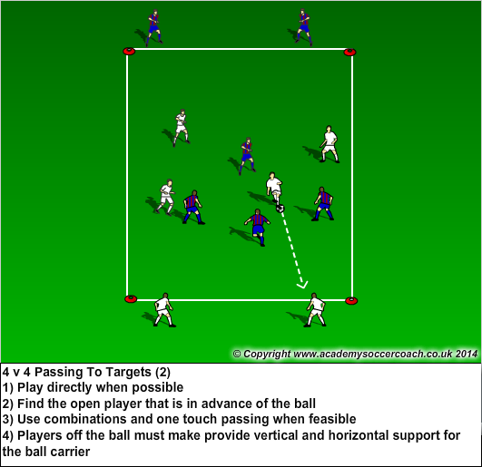

Game: 8 v 8 game with emphasis on finding forward players using penetrating passes.

Soccer Feature: Sportsmanship
Explain certain aspects of sportsmanship in the game. Have players shake hands/high five the opposing team at the end of the scrimmage. Losing and winning with class.

Week 9-Defending 2

Aim: To work together to defend as a team incorporating the skills learnt previously about individual defending

Skills
- Players should force the attacker away from the goal area
- Players should approach the ball carrier at an angle that gets between them and the goal
- Players should be on their toes ready to shift their momentum at any time

Key Principles

- When defending players can stand on the side that the goal is on, meaning that the attacker must dribble all the way around the defender to get to the goal.
- This is ‘goal side’ defending.
- When there are two defenders they can work together to dispossess the ball carrier.
- Two defenders can communicate to try and double team the attacker. They can synchronize their attempt to win the ball in this way
- Defenders can wait for the ball carrier to take a touch on the ball which takes it far away from their body, this allow the defender to possibly steal it.

Warm-Up:

Odd One Out
Every player has a ball and is dribbling it inside the square. When the coach shouts ‘switch’ players must leave the ball at their feet and start dribbling someone else’s soccer ball. When the coach shouts switch however they must remove one of the balls from the square so there are then less balls than players. If a player is left without a ball inside the square they can jog inside it until the coach shouts switch again. Every time the coach gives the switch command they can remove another soccer ball. The winners are the last two players left with a ball.

Games:

1 v 1 to a Cone

Players work in pairs with a single cone. Player with ball attempts to score by hitting the cone with the ball, while the defender protects the cone and tries to dispossess the attacker. If defender wins the ball, then they immediately attack the cone.

Stealers
Everyone in the square has a ball except for two players who are the ‘stealers’. They must try and steal a soccer ball form the other players in the square. If they steal a ball they must keep it. The players who have had their ball stolen become the new stealers. Progress by saying that if a ball goes outside the square it is lost and cannot be recovered. The winners will be the players at the end of the game still with a soccer ball.

Exercise:

5 v 3 To Goal

3 defenders stationed on each goal post play a ball 20 yards to 5 attackers then push out to pressure them attempting to dispossess or prevent a shot on goal.

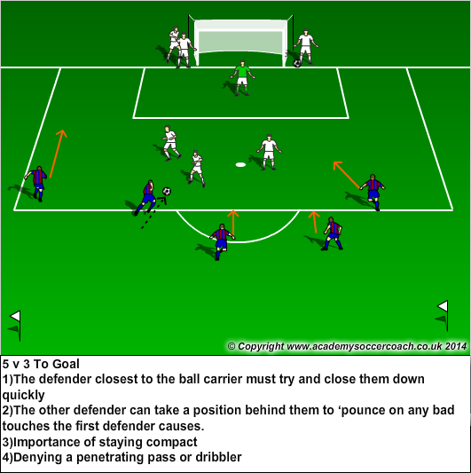

Game:
5 v 5 to Goal
Two teams of 5 play a game to goal with keepers. 40-50 yards space.
              - Defending team must play high pressure
              - Defending team denies penetrating dribbler
              - Defending team looks for opportunities to win the ball and counter

Game: 6 v 6 or 8 v 8 with the emphasis on team defending

Soccer Feature: Injury Time
The amount of time added onto the end of the usual game for any stoppages due to injury. It can be added onto the end of each half of the game.

Week 10-Attacking 2

Aim: To work on a team orientated method of attacking incorporating the individual skills previously learned

Skills
- Encourage players to spread out allowing for the ball to be played quickly across the field
- To get players to attack space with the ball
- Encourage the players to take ‘aggressive’ first touches

Key Principles
- If players are in space they are in a better position to receive a pass than those that are covered
- This gives those players time to dribble and attack the goal
- If a player is confronted with space they can attack freely and dribble into the space.
- They can attack space by taking a first touch straight into the space and towards the goal

Warm-Up:

Dribble Relay:
Players form two or three teams each with a ball. On command the lead players dribble 10-15 yards away around a cone and back to the second player who repeats until there is a winner.

Dribble to space:
Each player has a ball and starts close to the coach. On command, all players dribble into space as far away from the coach as possible until the coach commands them to stop.

Exercises:

Invisible Soccer
Split the players into two teams. There are no soccer balls! If a player has the ball, they place their hand on top of their head. They can pass it by saying the name of a teammate who will then put their hand on their head instead. Players are dispossessed when they are tagged by one of the opposition when they have the ‘ball’. A goal is scored when a player who has the ‘ball’ runs through the goal! Coaches must start the game by nominating the beginning ball carrier.

Coaching Points

- As there is no limit on the range of passing, players can spread out all over the field
- When confronted by an opposition player the ball carrier must look up for a pass into space
- Players must know their teammates names which will help in a normal scrimmage situation
- Quick passing moves the ball quicker than running with the ball

4 Goals Game
Set up a scrimmage field with four goals. There are two teams of 4 or 5. Players attack the two furthest goals while defending the two nearest ones.

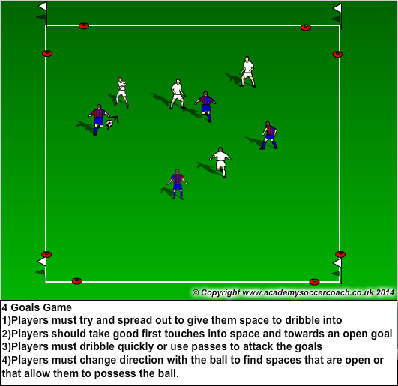

Game: 5 v 3 to Goal

5 Players attack 3 defenders and a GK. The attackers must try and score in 20 seconds or get off a quality shot at goal.
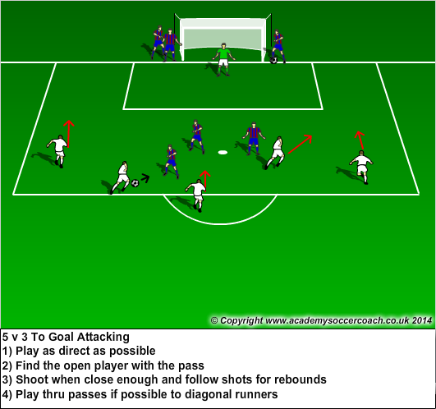

Game: 8 v 8 game to goals, with the emphasis on creating scoring chances off passes and runs.

Soccer Feature: Self-Training
Coach gives several ideas of exercises with and without the ball that a player should do on their own.

