Travel Week 1 Ball Mastery: 3-8th Grade
Warm-up (15 mins)
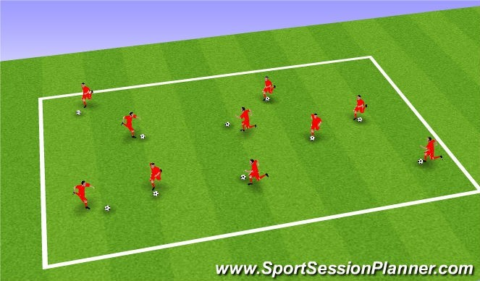
Set Up:
Each player with a ball
Players move between each other in open spaces with soccer ball and change directions on command. Use different surfaces to cut and turn the ball.
Encourage players to run in the space between 2 players to encourage movements in different directions.
Coaches instruction: Space – 5 seconds to find the most space
Toe taps, drab back and turn, roll the ball with sole of foot.
Aim:
To warm up and practice different foundation moves.
Coaching Points:
Always in ready position (on toes, knees bent).
Change of pace out of turn.
Small, close touches on the ball.
Technical Practice (15 mins)
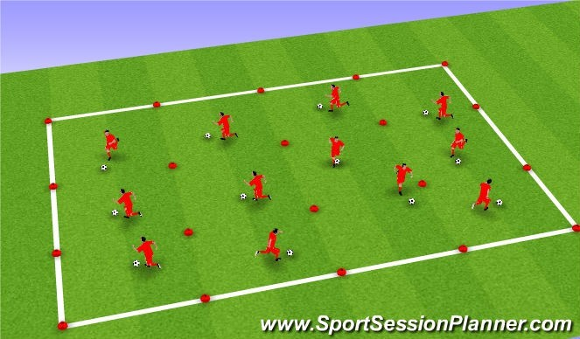
Set Up:
3 or 4 Players to in each corridor.
Players dribble up & down their specific corridor simultaneously, unopposed to start.
Using all parts of the foot (inside, outside, laces, sole).
Encourage players to use as many touches as possible from one side to the other. Introduce skill moves, Drag back when you get to a line to enforce change of speed and direction.
Aim: Establish and develop existing ball mastery skills.
Coaching Points:
Lots of small, close touches.
Head up to avoid interference.
Change speed with direction.
Keep ball moving.
Go over any key coaching points individually for foundation moves.
Add a defender to each corridor.

Skill Development (10 mins)

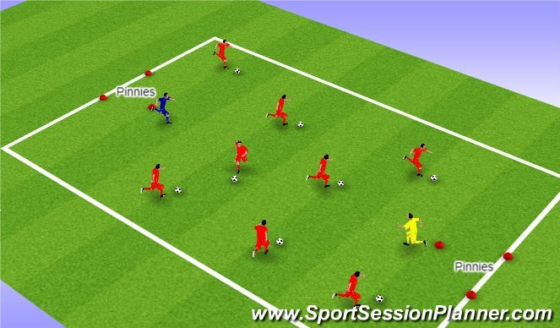
Set Up:
All players with a ball except two players with different pinnies on. Players with a pinnie have to steal the ball and dribble it to the triangle. Players who lose the ball can try and stop their ball going in the triangle. If ball goes into the triangle they pick up a pinnie and join that team.
Progression 1) Change defenders
Coaching Points:
Head up
Attack Space
Close control
Use different surfaces Change speed and direction Decision making
Protect ball-shielding while dribbling.
Small Sided Scrimmages 3v3 or 4v4 (15 mins)

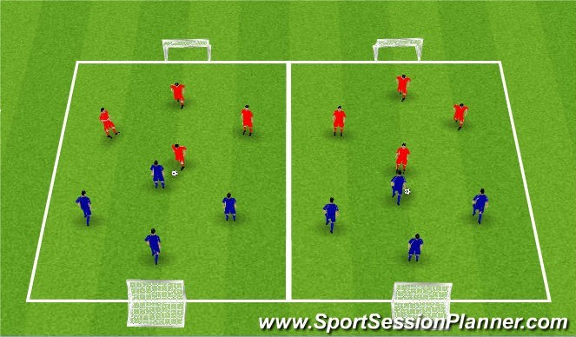
Description:
Small sided scrimmages. No more than 4v4. Play without goalkeepers. Introduce the basic rules of the game. Keep them playing for as much time as possible.
Coaching Points:
Reiterate all of the above points.
Keep them enthusiastic and engaged.
Use the Puggs goals or cones.

